In this session, Form will be introduced.
You may follow the instructions below, to create form with the appropriate elements.
Let’s start!
- HTML starter pack. You should have this starter pack ready for your exercises.
<!DOCTYPE html>
<html lang="en">
<head>
<meta charset="utf-8" />
<meta name="description" content="Demonstrates some basic HTML content elements" />
<meta name="keywords" content="HTML5, tags" />
<meta name="author" content="A Lecturer" />
<title>Lecture 3 - HTML 5 Basic Content Elements</title>
</head>
<body>

</body>

FORM
- Create <form> tag. Insert the scripting below after <body> tag. Given the form id and method.
<form id="detail" method="post">

</form>

TEXT BOXES (Create text boxes shown as following)
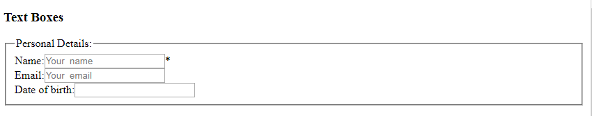
- Create the first textbox after <form> tag. You will find required = “required” for Name, this is to make sure the user must fill the textbox prior to submission. Please save and refresh your page.
<h3>Text Boxes</h3>
<label for ="fname">Name:</label><input type="text" id="fname"
name="fname" placeholder="Your name" required="required" />*<br/>
<label for ="femail">Email:</label><input type="text" id="femail"
name="femail" placeholder="Your email"/><br/>
<label for ="fdob">Date of birth:</label><input type="text" id="fdob" name="fdob"/><br/>

<label for ="fname">Name:</label>
** using <label> tag for insert the label for the text box. “fname” must be the same as the name id used in <input> tag.
<input type="text" id="fname" name="fname" placeholder="Your name" required="required" />
We need to specify the type for the input, in the example, the type is “text”
Placeholder is the short hint that described the text box.

- Let’s make the textbox area better. Insert <fieldset> and <legend> for the textbox area. Please save and refresh your page.
<fieldset>
<legend>Personal Details:</legend>
<label for ="fname">Name:</label><input type="text" id="fname"
name="fname" placeholder="Your name" required="required" />*<br/>
<label for ="femail">Email:</label><input type="text" id="femail"
name="femail" placeholder="Your email"/><br/>
<label for ="fdob">Date of birth:</label><input type="text" id="fdob"
name="fdob"/><br/>
</fieldset>

Fieldset – grouping for the related form controls.
Legend – caption for a fieldset

Check Box, Radio button, pull-down list (Create checkbox, radio button and pull-down list shown as following)
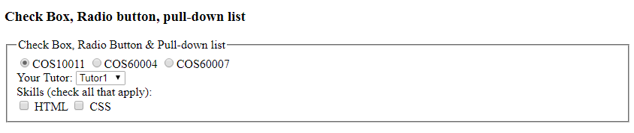
- Now let’s work on Check box. Please save and refresh to see the result.
<h3>Check Box, Radio button, pull-down list</h3>
<fieldset>

<legend>Check Box, Radio Button & Pull-down list</legend>
<input type="radio" value="cos10011" checked>COS10011
<input type="radio" value="cos60004">COS60004
<input type="radio" value="cos60007">COS60007 <br/>
</fieldset>

- Add Pull down list after Radio button. Please save and refresh to see the result.
….
<input type="radio" value="cos60007">COS60007 <br>
<label>Your Tutor:</label>
<select name="tutor">
<option selected>Tutor1</option>
<option>Tutor 2</option>
<option>Tutor 3</option>
<option>other</option>
</select>

- Now, let’s work on check box. Please save and refresh to see the result.
…
<option>other</option>
</select>
<br/><label>Skills (check all that apply):</label><br/>
<input type="checkbox" name="html" value="1"> HTML
<input type="checkbox" name="css" value="1"> CSS

Date and Time (Create Date and Time shown as following)
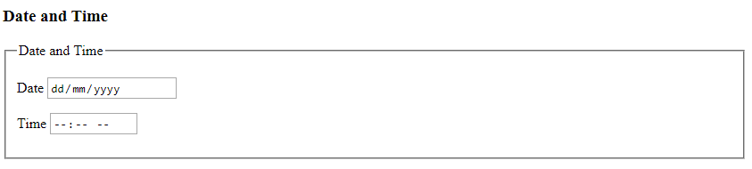

- First to work on Date. Please save and refresh to see the result.
<h3>Date and Time</h3>
<fieldset>
<legend>Date and Time</legend>
<p><label> Date
<input type="date" name="date"/>
</label></p>

</fieldset>

- Next, to work on Time. Please save and refresh to see the result.
<h3>Date and Time</h3>
<fieldset>
<legend>Date and Time</legend>
<p><label> Date
<input type="date" name="date"/>
</label></p>

<p><label> Time
<input type="time" name="starttime"/>
</label></p>

</fieldset>

Email & Phone (Create Email & Phone shown as following)
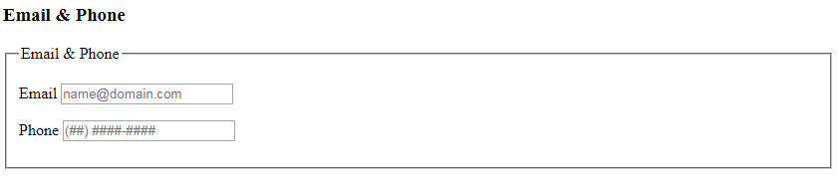
- Insert the following script for Email. Please save and refresh to see the result.

<h3>Email & Phone</h3>
<fieldset>
<legend>Email & Phone</legend>
<p><label>Email
<input type="email" name="contact"
placeholder="name@domain.com" required = "required"/>
</label></p>

</fieldset>

- Now, insert for Phone. Please save and refresh to see the result.
<h3>Email & Phone</h3>
<fieldset>
<legend>Email & Phone</legend>
<p><label>Email
<input type="email" name="contact"
placeholder="name@domain.com" required = "required"/>
</label></p>

<p><label>Phone
<input type="tel" name="phone"
placeholder="(##) ####-####" pattern="\(\d{2}\) +\d{4}-\d{4}" />
</label></p>
</fieldset>

Data list, Search and URL (Create Data list, Search and URL shown as following)
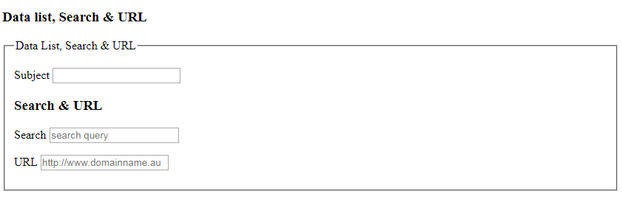
- Data List is different compare to pull-down list. Let’s try out the following script. Please save and refresh to see the result.
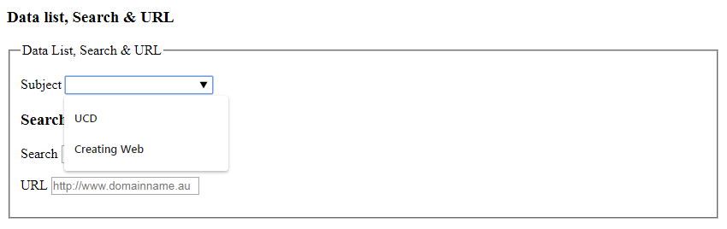

<h3>Data list, Search & URL </h3>
<fieldset>
<legend>Data List, Search & URL</legend>
<p><label>Subject
<input type="text" name = "sub" list="subjectlist">
<datalist id="subjectlist">
<option value="UCD">
<option value ="Creating Web">
</datalist>
</label></p>

</fieldset>

- Create a search with the following script. You may using javascript to make it works. Please save and refresh to see the result.

</datalist>
</label></p>

<h3>Search & URL</h3>
<p><label>Search
<input type="search" name="searchquery" placeholder="search query" />
</label></p>

</fieldset>

- Insert the following script for URLs insert. Please save and refresh to see the result.
<input type="search" name="searchquery" placeholder="search query" />
</label></p>

<p><label>URL
<input type="url" name="website"
placeholder="http://www.domainname.au" />
</label></p>
</fieldset>

Buttons (Create buttons shown as following)
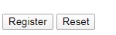
- Lastly is for buttons. Create 2 buttons – Register and Reset.
</br></br>
<button type = "submit" value = "Submit">Register</button>
<button type = "reset" value = "Reset">Reset</button>
</br></br>

